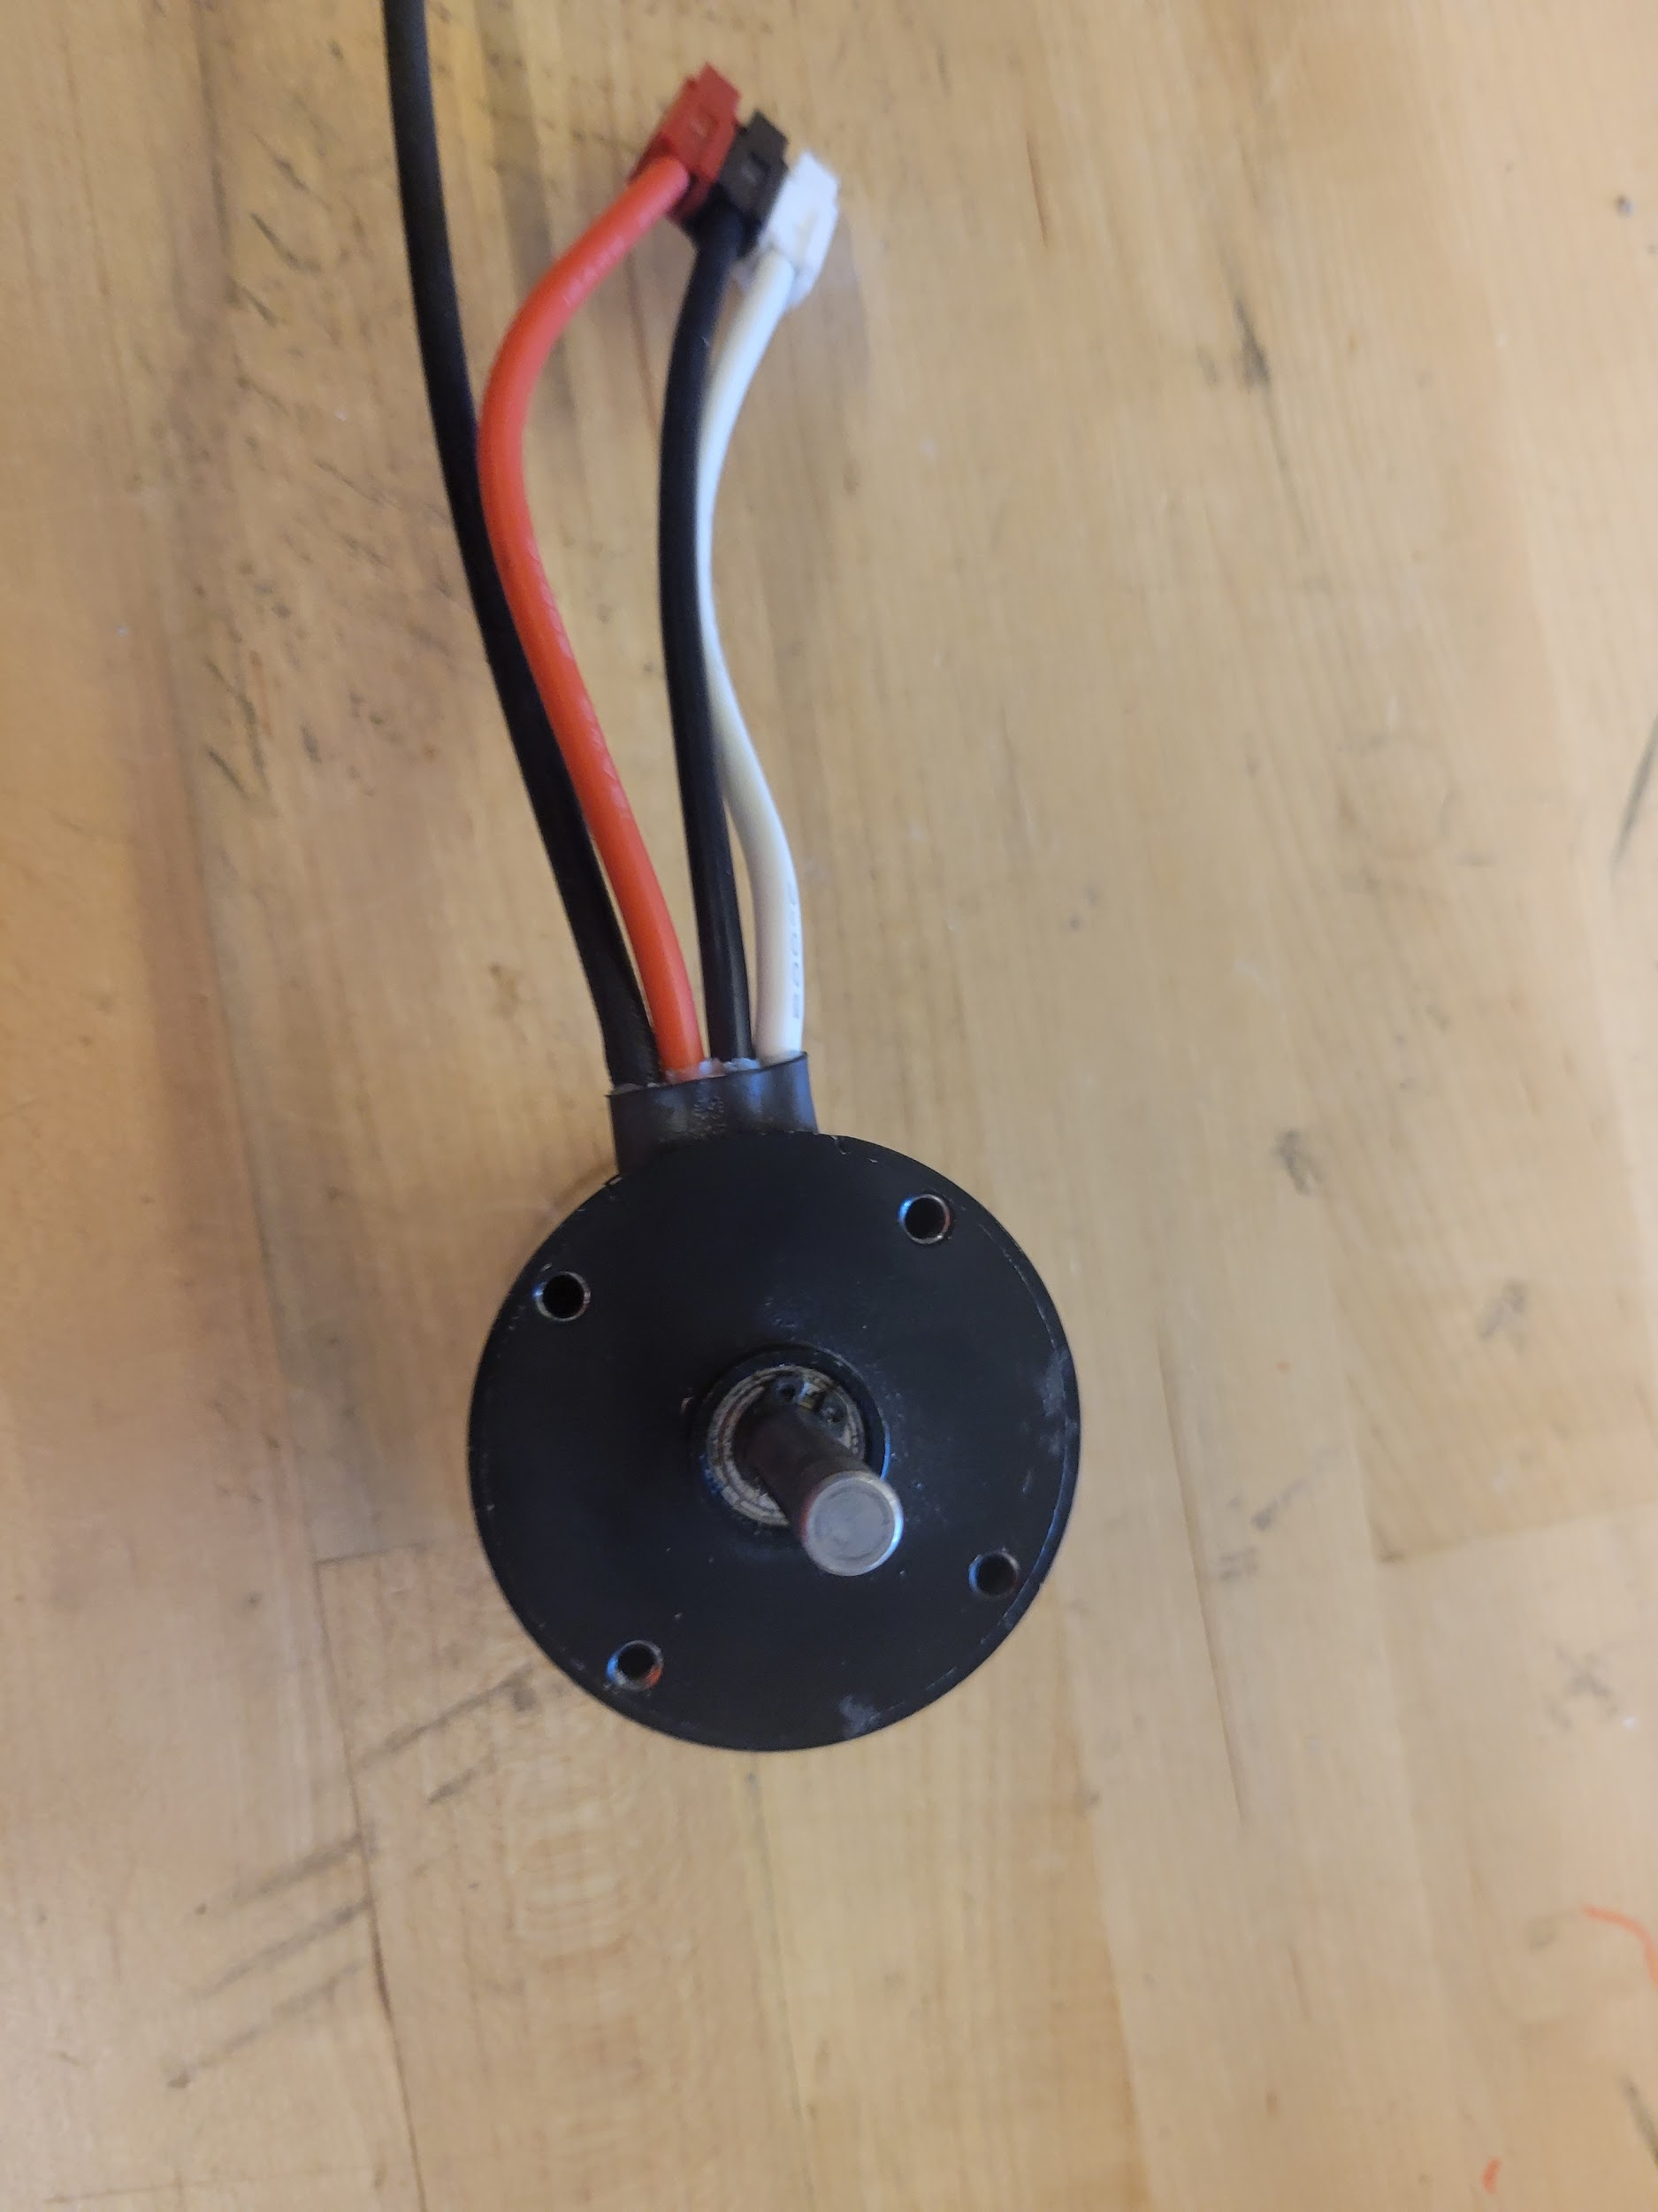
In code there are many types of variables integers, doubles, boolean, string, and objects that are defined. Any object being used would fall under object oriented programming. For example, see this motor on the right this is an object in code you establish by just simply calling the objects name in this case it's a CANsparkmax now you give this object a name lets call it bob now we need to what's called instantiate it, dont worry its not that hard it's simply do = new CANsparkmax(). If it has an error, it's because it has parameters, which means we need to give it information. Now for a CANsparkmax these are an id and a type now these can vary based on information but that goes more into how REV makes its products and we will go into those on a different time but for now we will do one and k.brushless so now our bob should look like this 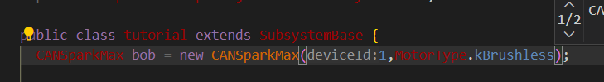
And there you go you have an object now this represents a motor that is tangible or real objects can also work for digital objects like mario he is considered an object in the games code. Now most objects are downloadable from outside sources so make sure to download them and import them into your code most of the time your intellisense will do this for you(I had to do this with rev). Now that we have an object what can we do with it? Well every object has a set of functions that can be called to make the object do something; these functions can always be found in the objects documentation. Just look through them all till you find what you need so lets code one of these operations. First were gonna call Bob just type in the variable name now just put a dot right after him this will cause intellisense to suggest every function variable and all the working parts of an object(we will talk on those when we learn how to make an object in a little bit) in this case were gonna call the set() function this will set the speed of the motor
Now whenever you call an object read up on the limits of it all of its inputs this only goes from 0 to 1 I chose .1 but since this was a double just remember the rules of types when inputting(ex doubles cant be negative) and there you go now you have a running motor you just did it you made and used an object in code it is really that simple

Making a object

Now for making them it's simply righting a file full of function for example let's say I made a file called microwave you can do this in any language but using java,c++ or even c# is highly recommended as these work best with this now we just need to add functions now just call that file as an object like we did before there you go you made an object

